**Types of Framework**

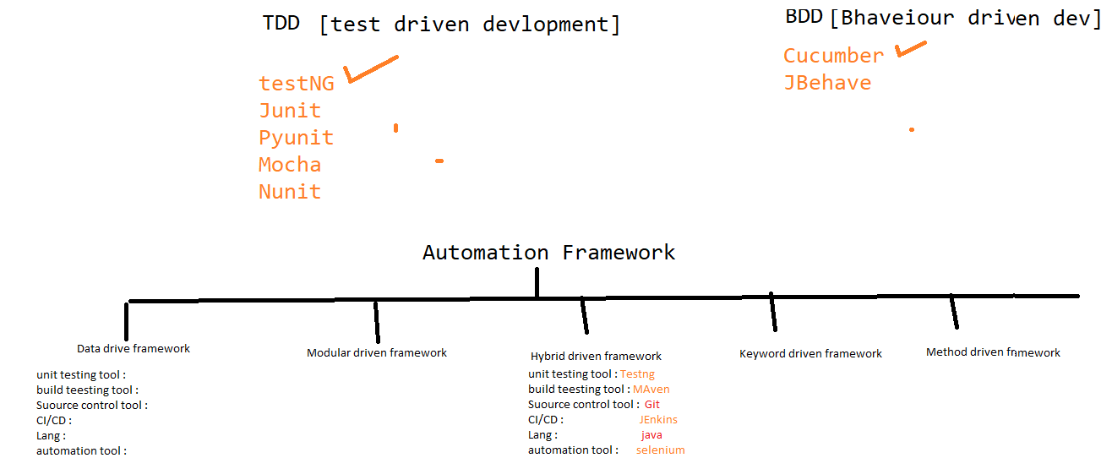

1. Data driven framework
2. Modular driven framework
3. Method driven framework
4. Keyword driven framework
5. Hybrid driven framework

**What is Data driven Framework**

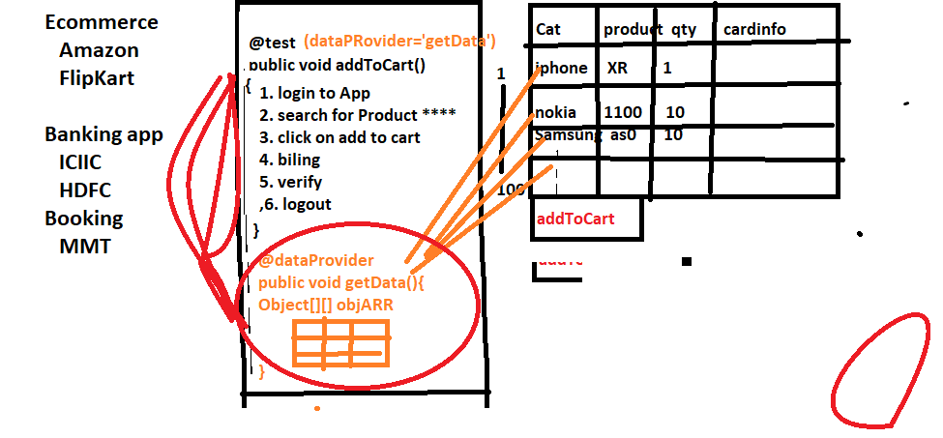

Whenever we need to test the application with huge set of data , we go for data driven framework

In data driven framework every test will have dedicated @dataProvider annotation & will have separate excel sheet for every test

@dataProvider

When ever need to execute same test with different set of data we go for dataprovider annotation

What?

Fetching the data from external Resource and utilizing it in the testScript or using data provider to read multiple data is called as data driven framework.

Why?

Automation rule says never hardcode the data in test script.

When?

Whenever the application has lot of test data then we prefer data driven framework.

Ex:

Bank, Ecommerce, Finance, travel etc…

**What is modular driven framework**

When ever application is huge / contains lots of module we prefer modular driven framework

In modular driven framework , all framework components will maintain in module wise

What?

Maintaining the test scripts, test data and suite xml files module wise in order to make debugging process easy is called as modular driven framework.

Why?

Modification and debugging is easy.

When?

Whenever the project is huge and has lot of modules and if there are frequent changes, we prefer modular driven framework.

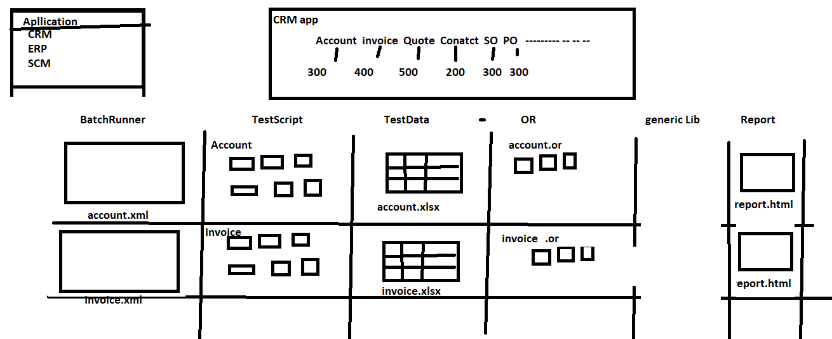

**What is Method driven Framework**

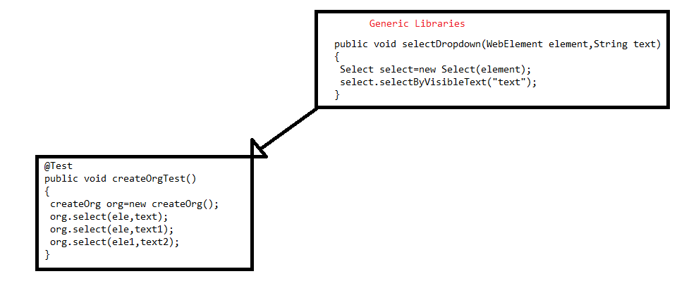

What?

Using the generic methods written in generic library into the test scripts instead of writing repetitive codes such that test scripts becomes optimised is called as method driven framework.

Why?

Test script optimization.

When?

Whenever there- is lot of repetitive actions in the application we prefer method driven framework.

**What is KeyWord driven Framework**

When manual test Engineer want to write Automation test script With less knowledge on automation tool & without knowledge coding we go for keyword Driven framework

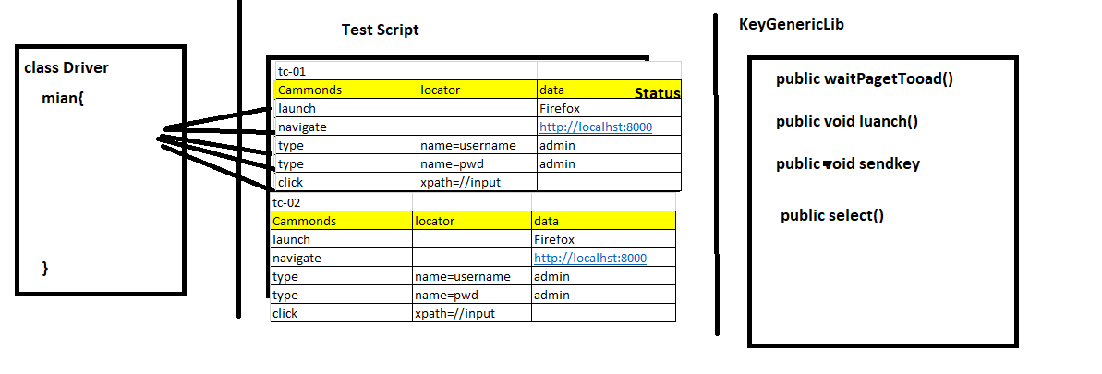

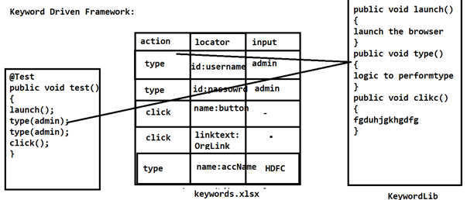

What?

Utilising the keys given in keyword document to perform any action is called keyword driven framework.

Why?

If the engineer is not well equipped with programming.

When?

Whenever manual engineers have to perform automation, they prefer keyword driven framework where keyword libraries will be designed and KT will be given to manual engineers.

**Hybrid driven framework**

Combination of 2 or more frameworks is called hybrid driven framework

Data Driven + Method Driven

Data Driven + modular driven

Data Driven + method driven + modular driven

Method driven + modular driven

Data driven + keyword driven

EG : the framework which we designed is hybrid because its combination of data driven + Modular driven + kewordword driven framework + Method driven

FRAMEWORK APPROACHES/TECHNIQUES

TDD:

Test Driven Development (TDD) is **a software development practice that focuses on creating unit test cases before developing the actual code**. It is an iterative approach that combines programming, the creation of unit tests, and refactoring.

or

What Is TDD?

TDD stands for Test Driven Development. In this software development technique, we create the test cases first and then write the code underlying those test cases. Although TDD is a development technique, it can also be used for automation testing development.

The teams that implement TDD, take more time for development however, they tend to find very few defects. TDD results in improved quality of code and the code that is more reusable and flexible.

TDD also helps in achieving high [test coverage](https://www.softwaretestinghelp.com/test-coverage/) of about 90-100%. The most challenging thing for developers following TDD is to write their test cases before writing the code.

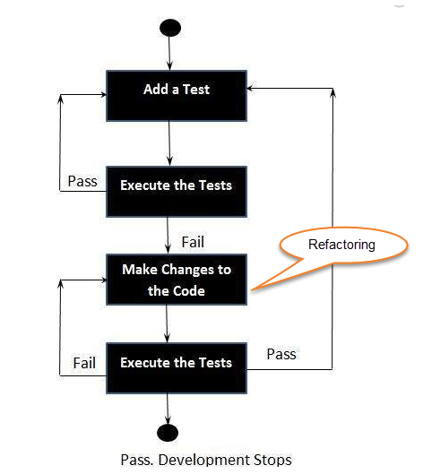

**BDD Framework**

BDD framework i.e. Behavior Driven Development is a software development approach that allows the tester/business analyst to create test cases in simple text language (English).

The simple language used in the scenarios helps even non-technical team members to understand what is going on in the software project. This helps and improves communication among technical and non-technical teams, managers, and stakeholders.

**Why Use BDD Framework?**

Before the BDD framework, everyone was using TDD. TDD works fine in software development, provided the stakeholders are familiar with the framework being used and their technical knowledge is sufficient. However, this may not be the case always.

BDD provides a path that acts as a bridge to overcome the gap between the technical and the non-technical teams because the test cases are commonly written in simple text, i.e. English. The main advantage of BDD is the low jargon and clearer approach which is easier to understand.



